**Practicum Summary Report**



Customer Intelligence Portal

***Guided by:*** *Professor Tao Li*

***Submitted by:***

*Rose Miao*

*Tanu Sharma*

*Vrinda Sehgal*

*Vrushti Khajanchi*

### Table of contents

**Introduction to the Project 2**

**Project Scope 2**

**Work Plan and Timeline 2**

**Key Project Findings/Deliverables 3**

**Benefits to AWS 3**

**Next proposed steps 3**

### 

#### 

#### Introduction to the Project

Customer intelligence is a key element in any business that ensures that the right product is introduced at the right time to the customer. At times, customers do not know that they need a product/service till the need is explained to them. Therefore, with the objective of helping AWS maximize their sales efforts we built a dynamic Customer Intelligence portal for them. This portal provides latest news about clients along with the sentiment associated(positive or negative) as well as identifies trends in the client company as well as in the industry as a whole. Along with this, metadata about the company has also been included to understand the scale of client’s operations. Overall, we intend to provide information to the Solution Architects of AWS such that it helps them decide the next best sales action and help them close the sales call as quickly as possible.

#### Project Scope

This final report outlines the work carried out by the team during the winter and spring quarters. The focus of the project encompassed data extraction, data cleaning, and data analysis for nine companies. The team's objective was to extract relevant data from various sources, perform sentiment and text analysis, derive insights from the meta data, create word cloud for pertinent words, and develop a supplementary dashboard based on the extracted data.

#### Work Plan and Timeline

During the winter quarter, the team dedicated their efforts to data extraction, data cleaning, and understanding the sentiments expressed in the collected news. In the spring quarter, the team collected metadata, identified important relevant words aligned with the company's needs, devised a suitable method for expressing sentiments, and finalized the dashboard, successfully completing the project as required.

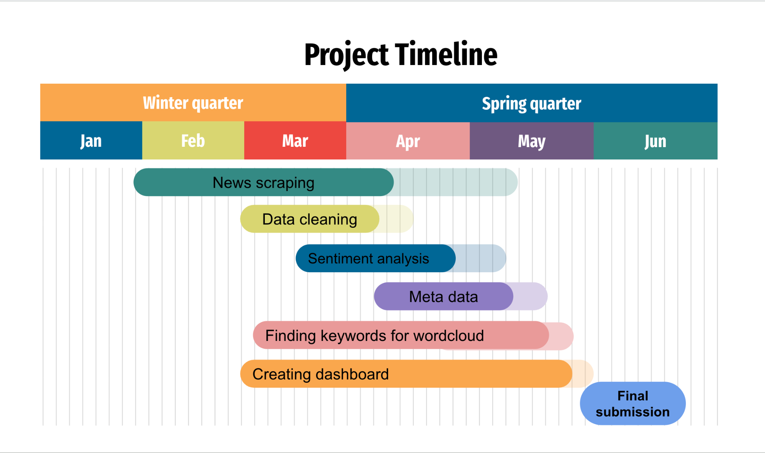

#### Key Project Findings/Deliverables

Throughout the project, several significant findings emerged, including a deep understanding of the industry trends, sentiment analysis, and the impact of key words in relation to the companies involved. These findings were instrumental in shaping the insights provided by the dashboard and offering valuable information for AWS and its customers.

#### Benefits to AWS

The company sponsoring the project is expected to greatly benefit from the developed dashboard. Firstly, the dashboard is tailored to the specific needs of the company, providing sentiment analysis tailored to the industrial news filters and standards set by AWS. Secondly, the inclusion of key words highlighted important trends and helped AWS gain a better understanding of each target company. The meta data analysis further enhanced the overall understanding of the company's success by examining financial and industrial trends.

The sponsoring company expressed their appreciation to the team for successfully completing the project and going the extra mile in continuously working on new developments that were needed. The team's dedication and efforts were instrumental in making this project a resounding success.

In conclusion, this report has provided an introduction to the project, outlined its scope, presented the work plan and timeline, highlighted key project findings and deliverables, and emphasized the benefits gained by the sponsoring company. The completion of this project has significantly contributed to AWS's customer intelligence portal, equipping the company with valuable insights to prioritize customers and drive successful sales actions.

#### Next proposed steps

In the next phase of this project, the Customer Intelligence Portal can be replicated by using in-house AWS services and tools such as SageMaker for the machine learning process, Comprehend for sentiment analysis and Quicksight instead of Tableau for creating the dashboard. Another major step would be to make the dashboard dynamic in nature such that it gets updated automatically when new data is available. Apart from this, the dashboard can be integrated with the software used by AWS to keep check of different services already in use by each client/company for easy comparison and opportunity scoping.